April 15, 2017
October 6, 7 & 8, 2017

Sponsored by the Fred Oldfield Western Heritage & Art Center
Dear Artists,
The Fred Oldfield Western Heritage & Art Center is honored to be sponsoring “The Oldfield Show” and you are cordially invited to participate. The show will be held in the Puyallup Fairgrounds Expo Hall on Oct 6, 7, & 8, 2017.
It was indeed a hard decision to go forward with the Show without Fred, but it was exactly what he wanted! So, go forward we will ~ full speed ahead!! Fred would always say, “It’s all about the kids” and you all will be helping us continue his legacy! This show will benefit the Western Heritage Center and the Children’s Art Program!
Show highlights include…Free Admittance to the Art Show…Free Admittance to the Evening Events…Free Wine and Cheese Tasting…Silent Miniature Auctions… Quick Draws…Live Quick Draw Auctions… Live Major Auctions…Steve Mitzner, Auctioneer!!...Free Musical Entertainment!

The venue for the show is the Expo Hall on the Fairgrounds ~ everyone under one roof! It is indeed a beautiful showcase for your incredible artwork and you won’t be disappointed!!
We fill the show on a First Come First Served basis!! The registration deadline is May 31st. A high-resolution photo of your work is required to participate in any of the publicity. Also, you will not be entered in any auction without a photo of your work. We will have the auction online this year and we need your photos!! Please also return your resume by May 31st so you can be included in the catalog.
Join us for a Successful, Exciting and Memorable Fine Art Show and don’t forget our Legendary, Down Home Hospitality!!
Warmest Regards,
Joella Oldfield
Executive Director

October 6, 7, & 8, 2017
October 6, 7 & 8, 2017

Sponsored by the Fred Oldfield Western Heritage & Art Center
Expo Hall - Puyallup Fairgrounds – Puyallup, Washington

SCHEDULE OF EVENTS
Friday, Oct 6th - 3pm to 10pm, Saturday, Oct 7th – 10am to 10pm
Receptions - 5pm, Silent Auction - 5-8pm, Quick Draw – 6-7pm, Auctions – 7:30pm
Sunday, October 8th – 10am to 4pm Benefit Auction 1pm, Show Closes - 4pm

DISPLAY INFORMATION
Display area: | - All Artist displays are in the Expo Hall (see diagram)  - Artists are responsible for their own displays, pegboards, table drapes, etc.
Display size: | 10’x10’ – 10’x15’ – 10’x15’ end spot – 10’x20’ – 10’x20’ end spot  (1 Artist per 10’x10’ Display – 2 Artists Maximum All Other Displays)  (You may combine 2 - 10’x10’ displays if you need a 10’x20’ display)
Deposit fees: | 50% Deposit fees are Non-refundable and Due by May 31st!
Display fees: | Display fees are Due in Full by September 1st!  $375 Per 10’x10’ Space - $425 Per 10’x15’ Space - $500 Per 10’x15 End Space –  $650 Per 10’x20’ Space - $700 Per 10’x20’ End Space

Check the following for Booth # and Size 10’ x 10’ Booth
#’s - 1, 2, 3, 4, 5, 6, 7, 8, 9, 10, 11, 12, 13, 14, 15, 49, 50, 51, 52, 53, 54, 55, 56, 57, 58, 59, 60, 61, 62, 63, 64,
10’ x 15’ Booth
#’s - 17, 18, 21, 22, 23, 25, 26, 27, 30, 31, 32, 33, 36, 37, 38, 39, 41, 42, 43, 44, 47, 48
10’ x 15’ End Booth #’s
19, 20, 28, 29, 34, 35, 45, 46
10’ x 20’ #’s 10’ x 20’ End Booth #’s
16, 65 24, 40 You may combine 2 – 10x10 booths to make a 10x20 booth.

Map of The Expo Hall
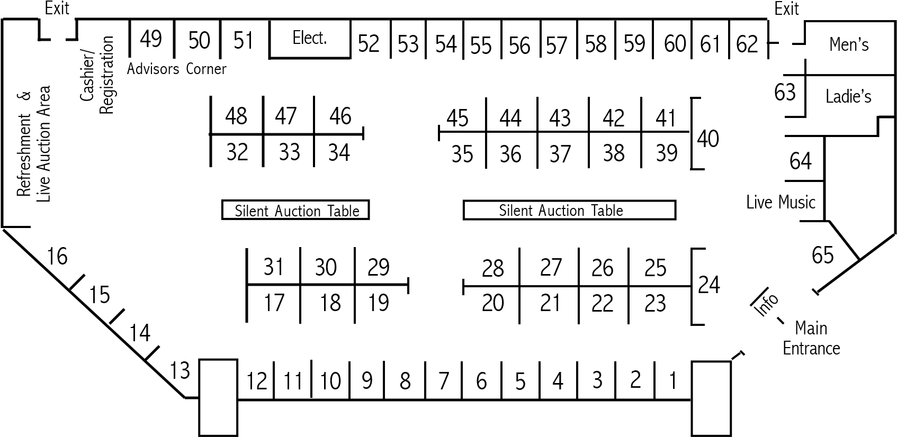

SHOW INFORMATION
October 6, 7 & 8, 2017

Sponsored by the Fred Oldfield Western Heritage & Art Center
Set up Times: | Thursday, October 5th from 4pm to 8pm or 9am to 2pm on Friday the 6th.
Display Signs: | Each display will be provided with a sign.
Directory: | A directory will be printed to show each display area number and artist.
Patron Invites: | If you wish to mail your patrons an invitation to the show, please complete that information on the show registration and we will mail them to you. You will need to add postage or you can send us your addresses & we will use our non profit rate & mail them for you.
Security: | There will be 24 hour Security on the premises.

AUCTION INFORMATION All artists may submit work for the Miniature Silent Auctions. There will only be 25 Quick Draw Artists each night. There will also be 20 Major Pieces each night. The participating artists will be selected by a committee. These will be Live Auctions. You may apply to be considered for the Live Auctions.
Quick Draws: | The Quick Draws will be by invitation only. Fri and Sat one hour Quick Draws. 50% split. Quick Draws will be created in the central auction area. Artists will be notified if they are selected.
Major Auction: | Major Pieces will be accepted by invitation only. These pieces will be in the Live Auction. 30% Commission. Artists will be notified if selected.
Miniature Auctions: | - Friday and Saturday Silent Miniature Auctions.  - 30% commission on the Silent Auction pieces.  - Two (2) pieces per artist may be submitted for the auctions.  - Absolutely NO lithographs and/or prints will be accepted.  - The maximum sizes for the mini pieces are:  9”x12” or smaller image size for paintings – NO exceptions! 9” or smaller for sculptures.  - You may set an opening bid on your Silent Auction pieces.
Buy Back Fee: | Mini Auction: 10% or $25 (whichever is greater) with a maximum of $100. ($25 minimum - $100 maximum)
Major Auction: | 10% or $50 (which ever is greater) with a maximum of $350. ($50 minimum - $350 maximum)
Minimum Bid | You may set a minimum bid on any auction item, however we reserve the right to reject any auction item that has what we feel is an unreasonable minimum.
Buy Back Procedure: | Buy backs will only be on Saturday and Sunday at 10:00am. Then you can return your piece to your display.
Auction Deadline: | If you are participating in the show you may bring your miniature paintings with you and turn them in upon your arrival. HOWEVER, WE DO NEED YOUR PAPERWORK WITH SIZE, TITLE & MINIMUM BID BY AUGUST 1ST! Please send that in or email it to us. Please submit photos of any work you want considered for the main auction by August 1st. It will be screened and you will be notified. We appreciate your cooperation as we are trying to simplify this process for you and for our staff.
Auctioneer:  Benefit Auction | “Cowboy” Steve Mitzner will preside over the Auctions.  Sunday at 1pm will be the benefit auction. This auction may consist of originals and prints. All proceeds will benefit the children’s “Experience Art” program at the Fred Oldfield Western Heritage & Art Center. 100% Donations.

PERTINENT DATES AND INFORMATION
October 6, 7 & 8, 2017

Sponsored by the Fred Oldfield Western Heritage & Art Center
Show Dates: October 6, 7 & 8, 2017
Show Registration Deadline: May 31, 2017
Display Deposit Due: May 31, 2017
Final Display Payment Due: September 1, 2017
Auction Piece Deadline: August 1, 2017
Show Set Up Times: Thursday, October 5th ~ 4-8 pm or 9am-2pm on Friday the 6th
Director: Joella Oldfield
Office phone: (253) 752-9708 or (866)-445-9175
Office address: Fred Oldfield Western Heritage & Art Center
PO Box 1539, Puyallup, WA 98371

HOTEL ACCOMMODATIONS
Hampton Inns of Puyallup Fairfield Inn & Suites - Marriott
1515 So. Meridian - Puyallup 98371 202 15th Ave SW - Puyallup 98371
253-770-8880 1-866-430-2692 253-770-3100
2 minutes South of Expo Hall 3 minutes South of the Expo Hall
The Best Western Park Plaza Crosslands Economy Studios
Puyallup 1-888-204-5804 Extended Stay Hotels
Puyallup 1-800-804-3724
You must say you are with the Western Art Show.

CAMPING ACCOMMODATIONS
Fairgrounds Campground: Includes Water, Power & Sewer (No Showers) Please call the Fairgrounds directly for reservations 253-845-1771.

SHOW REGISTRATION FORM
TO HOLD YOUR SPACE IN THE SHOW PLEASE RETURN THIS FORM BY MAY 31st TO:
Fred Oldfield Western Heritage & Art Center - P.O. Box 1539, Puyallup, WA 98371

Artist_____________________________________________ Helper _________________________________
Address__________________________________________________________________________________
City ____________________________________________ State _______________ Zip _________________
Telephone _______________________________________ Cellular _________________________________
Email ____________________________________________________________________________________
Washington State Tax ID# ___________________________________________________________________
(For a temporary tax # go to www.dor.wa.gov - then “doing business” tab, then “temp. business” tab)

DISPLAY SPACE INFORMATION
_________ I WOULD LIKE THE SAME SPACE AS LAST YEAR.
Please mark the size space and number you prefer___________________
_________ I WANT TO RESERVE A $375 - 10’x10' DISPLAY AREA.
1st Choice #___________2nd Choice #__________3rd Choice #_________
_________ I WANT TO RESERVE A $425 10’x15' DISPLAY AREA.
1st Choice #___________2nd Choice #__________3rd Choice #_________
_________ I WANT TO RESERVE A $500 10’x15' END AREA.
1st Choice #___________2nd Choice #__________3rd Choice #________
_________ I WANT TO RESERVE A $650 10’x20' DISPLAY AREA.
1st Choice #___________2nd Choice #__________3rd Choice #_________
______ I will send a 75 word resume for the show directory by September 1st!
***(If we do not receive a resume, you not be in the Catalog.)***
______ Please use last year’s Resume
______ Please print my booth information for the directory and my name sign as follows
(i.e. Fred Oldfield-Western Oils________________________________
______ I will send my list of patrons by August 1st to have an invitation mailed directly to them.
**PLEASE FILL OUT & RETURN BOTH PAGES – DISPLAY INFO & INTENT TO PARTICIPATE BY MAY 31ST **

INTENT TO PARTICIPATE IN THE AUCTION/S FORM
______ I will submit (max 2) ______pieces for the miniature Auction

______ I will send my auction form information by August 1
October 6, 7 & 8, 2017

Sponsored by the Fred Oldfield Western Heritage & Art Center

_____ I am doing the auction only and will SHIP MY AUCTION PIECES BY AUGUST 1st

______ I will submit my Auction photos by Aug 1st & deliver my auction pieces to the show by October 5th

______ Please consider me for one of the Quick Draws
(You will be notified of acceptance)

______ Please consider me for one of the Major Auction Pieces
(You will be notified of acceptance)

HOLD HARMLESS AGREEMENT
(Must be completed in order to participate in the show and or auction)
__________________________________________herein referred to as Exhibitor will indemnify THE FRED
OLDFIELD WESTERN HERITAGE CENTER, JOELLA OLDFIELD, KARRIE NEVIN, FRED OLDFIELD, STAFF, & THE WESTERN WASHINGTON FAIR, ITS OFFICERS, DIRECTORS,
AGENTS & EMPLOYEES save it harmless from and against any and all claims, actions, damages, liability and expense in connection with loss of life, personal injury and/or damages to property arising from and out of any occurrence in, and upon or at the leased premises including the parking lot or any property adjoining the premises occasioned wholly or in part by any act of omission of exhibitor or its agents, contractors and employees.
Signed ___________________________________________________ Date: __________________________

**PLEASE FILL OUT & RETURN BOTH PAGES – DISPLAY INFO & INTENT TO PARTICIPATE BY MAY 31ST **

AUCTION REGISTRATION FORM
Send by AUGUST 1st with Artwork or Photos!
Artist _____________________________________________________________________ Address ___________________________________________________________________
City ___________________ State ______ Zip__________ Phone ___________________

Miniature Auction
Please fill in your minimum opening bid!! Your wholesale price is a good place to start, then the buyers can keep bidding it up. If you start too high, the buyers have no room to bid. Any questions, please call.
- Title ____________________________________ Minimum OPENING Bid _______________
Size ____________________________________ Media______________________________
- Title ____________________________________ Minimum OPENING Bid _______________
Size ____________________________________ Media________________________________

Major Auction
Please consider the following piece(s) for the Major Auction Please include photo for judging of the Major pieces.
- Title ____________________________________ Minimum ACCEPTED Bid _____________
Size ____________________________________ Media _______________________________
- Title ____________________________________ Minimum ACCEPTED Bid _____________
Size ____________________________________ Media _______________________________
THE DEADLINE IS AUGUST 1, 2017 for AUCTION ITEMS OR PHOTOS ONLY

Ship Paintings to: Joella Oldfield – 525 Broadway #301 – Tacoma, WA 98402

Hand Deliver: Western Heritage & Art Center – 110 9th Ave SW - Puyallup, WA 98371

253-752-9708

